Title: Linux process investigation
Date: May 16th 2026
Analyst: Savon Masters

Summary

Processes are ran countless times on a system, to catch ones that are impactful you have to see the difference between dangerous and safe items. I simulated an attack in the way of a process, I investigated it to find the root, and replied with action to the attack.

Investigation
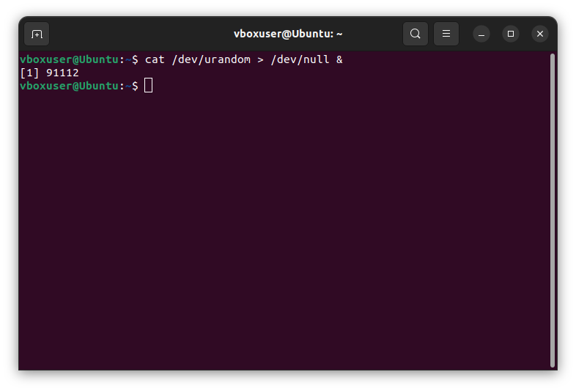

I inserted “cat /dev/urandom > dev/null” into the command line to make an event with high CPU usage.

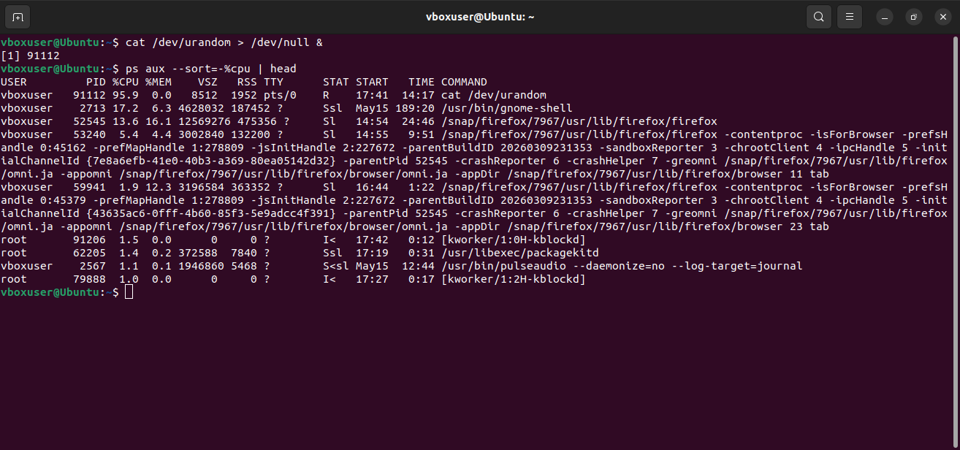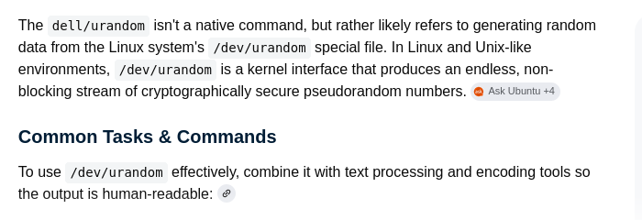

On the system I find all processes information by using the “ps aux –sort=-%cpu | head” One stood out at the beginning for a few different errors; the command being ran is “cat /dev/urandom”, cat is not a typical process that is ran and /dev/urandom prompts the cryptographically secure pseudorandom number generator (CSPRNG) to generate ongoing amount of numbers to a system which would be effective for a DOS attack. Other than the command the CPU is very high for an individual process ”95.9%”. With the other data I could see the process ID “91112”.

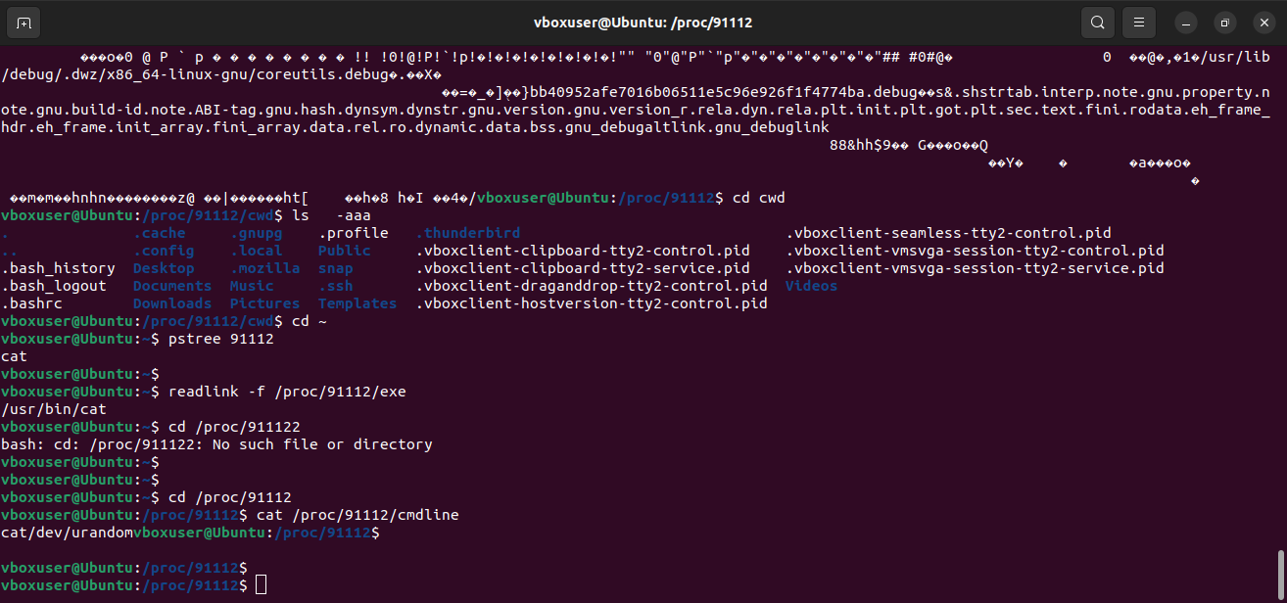

When I identify the process ID I can build piece by piece the process's family tree. I used the “pstree 91112” to find the parent process, the “readlink -f /proc/91112/exe” to find the exe location on the system and the “cat /proc/91112/cmdline” to view the process’s original command.

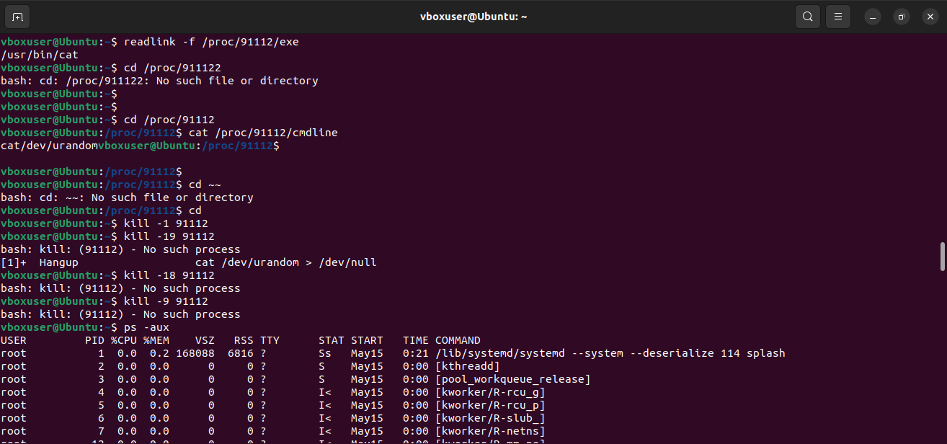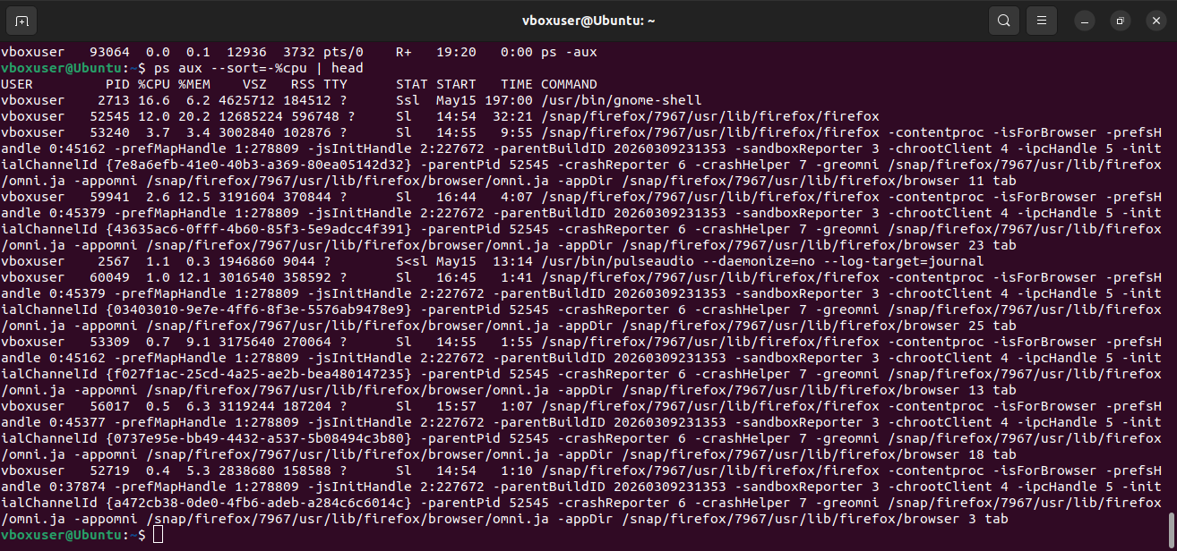

To shield the system and restore it I set up the “kill -19 91112 and kill -9 91112” to suspend and kill the process. It needs to be determined if the process was destroyed, I ran the same command from before and there was no copy of the process.

Conclusion

To end, an attack with a process took place, it’s makeup was high CPU usage and making the host extend itself for connectivity. I pulled back the process’s user creation, ID, location, commandline, and parent process and enforced safety response of the kill and suspension on the process.

IOCS

- The process “cat /dev/urandom > /dev/null” being ran,
- The use of cat in the command line of the process.
- Rest of the processes using normal CPU usage while one is taking “95.9%”

Recommendations

- Develop an endpoint detection alert to go over all processes CPU usage goes beyond 80%.
- Keep monitoring processes commands it will show attacks placed on system.
- It only needs to be short amount of elevated accounts with executions powers to avoid malicious behavior.

Things I learned

- Have caution with processes with increased CPU usage to watch for different processes.
- A processes overview through connected commands.
- A better paced way to respond to an incident without regrowing another one.
- A process being at the top of the chain for an attacker to cause damage to a system.

